**Cloud Computing Lab**

Assignment – x  
**\*Title\***

* Anudeep CVS

(PES1UG19CS070)

**Screenshots**

1. The 2 buckets (pes1ug19cs070 & pes1ug19cs070-resized) are created

**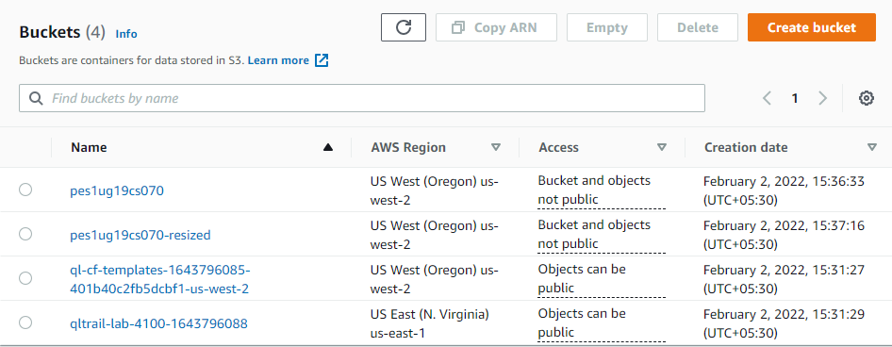***PES1UG19CS070_1a.png*